FHIA Website
How to Post SIMPLE MessageS to the News
A. Login

• Go to http://fhia.org/login

• Type ID and password.

Click the “I’m not a robot” box. You may be asked to click on some images to show that you are not a robot.

B. Open the New Post Screen

At the top of the screen, there is a black bar. You see this bar after logging in.

- Select: '+ New' -> 'Post'.

This takes you to the 'Add New Post' page. An almost identical 'Edit Post' page is used if you want to edit a post later.

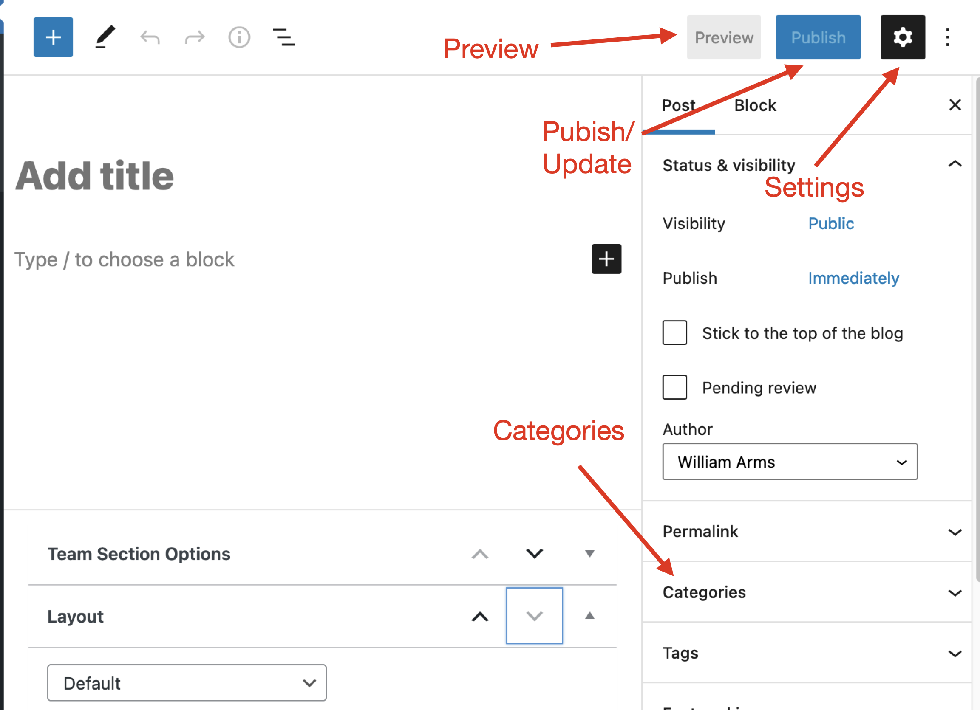

The Settings panel

As shown in the figure, on the right of the screen there should be a panel with settings for the post. If it is not visible, click the Settings icon (the cog wheel at the top right of the page).

Sometimes, while editing the post, this panel is replaced by a short editing panel. To restore the Settings panel, click on the title of the post.

C. Create a Simple Post

A simple post has a title and a text body. All formatting is done by the program.

Title of post

Click on the words "Add title" and type the title of the post.

Text of post

Click on the words "Type / to begin a block." There are two ways to insert text:

- Type the text.

- Copy and paste from a file on your computer. To avoid formatting problems, it is recommended that you copy and paste one paragraph at a time. If the text is formatted, most formatting in lost, but bold and italic fonts may be retained.

To set post to appear on home page

In the Settings panel on the right side of the screen, there is a menu item 'Categories’. Click on the caret (the little v) beside it to reveal a list of categories. If the post is to appear on the home page, click the 'Home page' box.

D. Preview

When on the 'Add New Post' page or the 'Edit Post' page, you can preview the post.

- At the top of the screen, there is menu item 'Preview'. Click on it and select the submenu item 'Preview in a new tab.' This opens the post in a new tab. Keep the Desktop option checked.

- After reviewing the post close the new tab.

You can make changes to the post in the original tab. Do not edit the Preview tab.

E. Publish or Update a Post

To make a new page visible to everybody, you 'Publish' it. If you then edit the page, you 'Update’ it to make the changes visible.

At the top right of the screen there is a blue button, labeled either 'Publish' or 'Update'.

Click 'Publish' or 'Update’. The post will appear on the News and Events page on the website.

If the 'Home page' category was selected it also shows at the bottom of the home page.

F. Edit a Post

To edit a post after it has been published you must be logged in.

Find the post you wish to edit. There are two ways to do this

- Go to the News and Events page on the website and click on the individual post. At the bottom of the post there is the word 'Edit'. Click the word 'Edit' and the 'Edit Post' page is opened.
- Via the Posts entry on the Dashboard menu. Hover over the title of the individual post and click on Edit.

The ‘Edit Post’ page is almost identical to the 'Add New Post' page, except that the 'Publish' button is now labeled 'Update'.

You can now make changes to the post. If you want to add a new paragraph, put the cursor at the end of the paragraph before and press Enter. You can also click between paragraphs and a horizontal line with a + will display. Click the + to enter a new paragraph or an image.

Use 'Preview' to review changes, and 'Update' to publish the revised changes.

G. Add an image

There are two simple ways to add an image to a post, add a featured image or insert an image between paragraphs.

Add a featured image

A featured image is an image that is displayed at the top of the post, under the title.

Do not use a featured image on a post that will appear on the home page.

To add a featured image:

- When creating or editing a post, in the menu on the right side of the screen, there is a menu item 'Featured image’.

- Click on it and a gray box 'Select featured image’ appears.

- Click on it and a new panel appears with two options, 'Upload files' and 'Media Library'. See below for information about how to upload files or select from the Media Library.

Insert an image between paragraphs within a post

To insert an image between two paragraphs, the editor creates what it calls a new block. To create a new block:

- Click on the gap between two paragraphs. A line appears with a + sign. Click on the + sign.

- A panel appears with several icons. Click on the Image icon.

- Another panel appears with several options, including 'Upload' and 'Media Library'. See below for information about how to upload files or select from the Media Library.

Upload an image or attachment from your computer

To insert a picture, or an attachment such as a PDF file, into the page.

- Select the 'Upload' tab.

- Select a file from your computer as indicated. (The user interface sometimes but not always gives an option to drag a file from your computer.)

- Click 'Select featured image'.

- The file will be copied into the Media Library and added to your post.

Pictures will be inserted into the post. Other attachments, such as PDFs, will not appear in the post, but a link to the file will be placed in the text.

Images and attachments (using the Media Library)

The web site has a Media Library to store pictures and attachments.

If the file is already in the Media Library:

- Click the 'Media Library' button. Locate the desired image and click 'Select'.

H. Delete a post

To delete a post that has been posted, you must be logged in. In the 'News' section of the web site, click the small 'Edit' link at the bottom left of the post. This takes you to the editor.

If necessary, in the editor, click on the title to restore the Settings panel.

Click the "Move to trash" box in the Settings panel

