Notes on preparation of PDFs for minutes and other reports for FHIA website

These notes provide guidelines for creating PDFs that (a) will improve the presentation of Internet search results that retrieve the documents and make it easier for users who retrieve, view or save the documents to understand the document context and (b) will be easier for future webmasters to manage.

File naming
The recommended pattern for the name of the final version of a document is to start with "FHIA_" followed by the year. This makes it easier for a webmaster to manage the accumulated collection of documents. Do not use spaces in filenames; replace them by underscore characters. Dates should always be in yyyymmdd or yyyy-mm-dd form. See the following examples:

For meeting minutes
FHIA_2018_Annual_Meeting_Minutes_20181022.pdf
FHIA_2008_Officers_Meeting_20080123.pdf
FHIA_2018_Community_Meeting_Minutes_20181205.pdf
For reports
FHIA_2020-21_PresidentAnnualReport_2021-10-27.pdf
FHIA_2020-21_TreasurerAnnualReport.pdf
FHIA_2020-21_DirectoryReport_2021-10-25.pdf

File properties
The PDF should have appropriate properties (metadata) for the document's Title and Author. This is for the benefit of future users of the document files and for better presentation of results from Internet searches. For example, Google will show the Title rather than the file name.

Sample Titles
Forest Home Improvement Association, Annual Meeting, October 22, 2018, Minutes
FHIA Officers Meeting, January 23, 2008, Minutes
Forest Home Improvement Association, Community Meeting, December 5, 2018, Minutes
Sample Author
Heather Beasley (FHIA Treasurer)

If you have a copy of Acrobat Pro, you can edit the PDF document properties there using File Properties in the Description tab. An alternative is to set the properties in your word processor before you create the PDF.

Creating the PDF from Microsoft Word
Do not use the operating system's Print to PDF option.

The exact steps depend on the versions of Word and operating system you are using.

It is convenient to start by saving your document in Word using the desired file name. That way, when you make the PDF, it should automatically have the right name. [Note: the default file format for Word has a .docx extension, but you may not see the extension unless you have chosen to show them in your folder/directory listings.]

In Word, set Title and Author in File Properties/Summary or File/Info
Sample Title
Forest Home Improvement Association, Annual Meeting, October 22, 2018, Minutes
Sample Author
Connie Stirling Engman (FHIA Secretary)

[Note: If you have Acrobat Pro and Word, you may see a top-level Acrobat option in the Word menu ribbon. You can certainly use that if you are familiar with it.]

Still in MS Word, depending on version, you should find a Save As or Export option that lets you make a PDF. Below are examples with screenshots:

Save As PDF. Choose option Best for Electronic Distribution and Accessibility (not the option recommended for printing).
[Screenshot is from an up-to-date version of Word on a Mac in February 2022.]

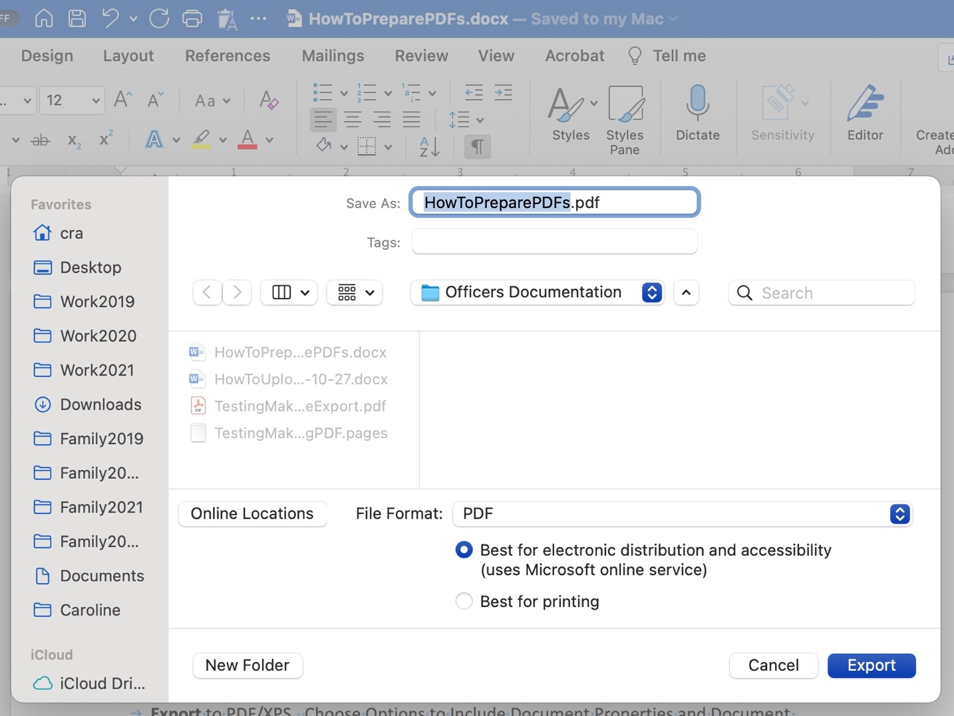

OR

Export to PDF/XPS. Choose Options to Include Document Properties and Document Structure Tags for Accessibility if you see them. Or choose option for Standard rather than Minimum Size as in screenshot below.
[Screenshot is from Word on Windows 10 in January 2022.]

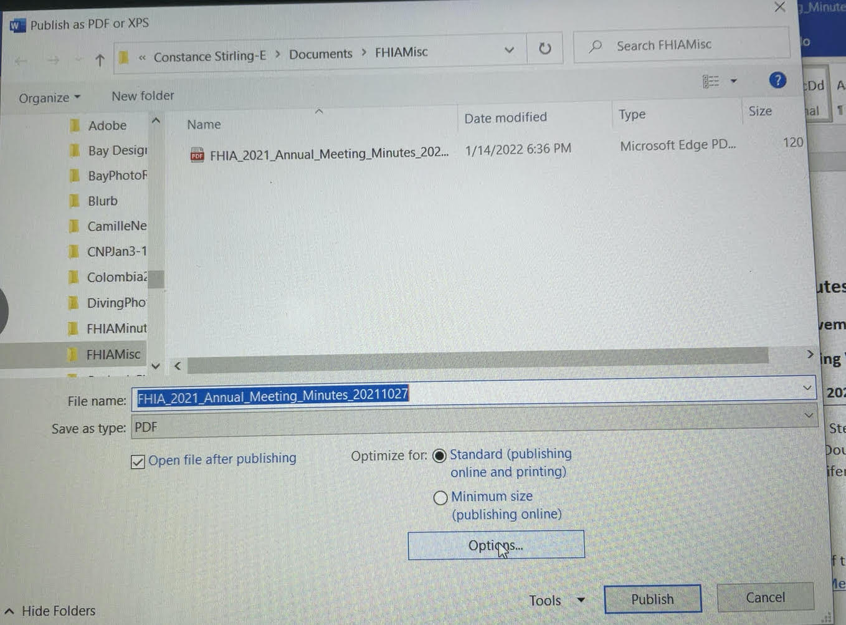

Finally, use whatever tool you have available to check that the PDF has the Title and Author properties that you added. For example,
- in Adobe Acrobat Reader, use File Properties
- in Preview on a Mac, show the Inspector (under Tools)

Creating the PDF from Apple Pages
Apple Pages does not have the concept of document properties and the MacOS does not have a utility that lets a user edit the properties in a PDF file. Nor does there appear to be a free and trusted app that has that functionality. If you have Acrobat Pro, Export to PDF in Pages and edit the properties in Acrobat Pro. If you have Microsoft Word, Export to Word (choosing the .docx option) and follow the instructions for editing the properties and creating the PDF in Word from above.

If you have neither Word or Acrobat Pro on your Macintosh computer, the simplest thing is to find someone who does, for example, Caroline or Bill Arms.

For very technical Mac users, there are some free options for adding Title and Author properties to a PDF created in Pages, at least as of early 2022. I have successfully used option 1 but not tried option 2.
- If you are happy using the Terminal (Command line) interface on your Mac and running applications that can only be run from there, you can download and use ExifTool [https://exiftool.org/].
- MacOS comes with a scripting tool called Automator which is reported to allow one to Set PDF Metadata.

Caroline Arms. March 1, 2022

